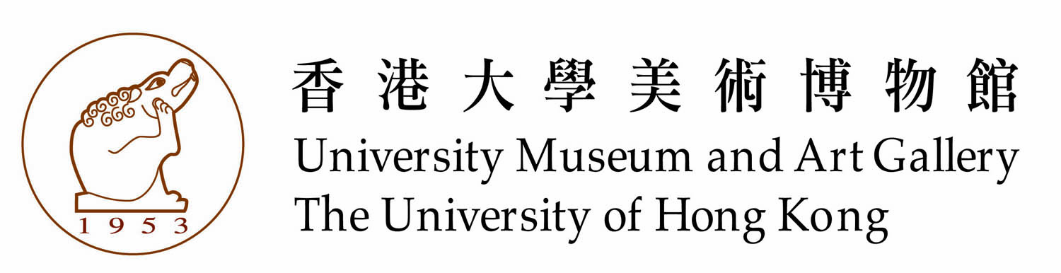

|  |  |  |
| --- | --- | --- |
| Images/ 圖片 | Captions | 說明 |
| C:\Documents and Settings\Administrator\桌面\Conforming to Vicinity\From Pauline\otto_A_0b.jpg  C:\Documents and Settings\Administrator\桌面\Conforming to Vicinity\From Pauline\提供给香港站折页\李天伦 04.JPG | **Developing Soundscapes**  Sound Installation  Otto Tin Lun LI (Hong Kong)  2014 | **發展中的音域**  聲音裝置  李天倫 (香港)  2014 |
| C:\Documents and Settings\Administrator\桌面\Conforming to Vicinity\From Pauline\提供给香港站折页\林欣杰 04.JPG  C:\Documents and Settings\Administrator\桌面\Conforming to Vicinity\From Pauline\提供给香港站折页\林欣杰 01.JPG | **Urban Code: Flâneur Sculpture**  Interactive Installation  Keith LAM (Hong Kong)  2014 | **城市密碼: 漫游者雕塑**  互動裝置  林欣傑(香港)  2014 |
| C:\Documents and Settings\Administrator\桌面\Conforming to Vicinity\From Pauline\洪强 01.JPG | Video Installation  Keung HUNG (Hong Kong)  2014 | 錄像裝置  洪強(香港)  2014 |
| C:\Documents and Settings\Administrator\桌面\Conforming to Vicinity\Press Invitation\Images\Carol_1.jpg  C:\Documents and Settings\Administrator\桌面\Conforming to Vicinity\Press Invitation\Images\Carol_2.jpg | **Intersection – Blood Lines**  Mixed Media Installation  Carol KWOK (Macao)  2014 | **交匯 – 血線**  綜合媒材裝置  郭倩齊 (澳門)  2014 |
| C:\Documents and Settings\Administrator\桌面\Conforming to Vicinity\Press Invitation\Images\Bonnie Kitty_1.jpg | **Water**  Video  Bonnie LEONG (Macao)  Kitty LEUNG (Macao)  2014 | **水**  錄像  梁慕貞(澳門)  梁慕潔 (澳門)  2014 |
| C:\Documents and Settings\Administrator\桌面\Conforming to Vicinity\Press Invitation\Images\Eric_1.jpg  C:\Documents and Settings\Administrator\桌面\Conforming to Vicinity\Press Invitation\Images\Eric_2.jpg | **Paradise Series**  Painting (Wood, Technical Drawing Pen)  Eric FOK(Macao)  2014 | **樂園系列**  繪畫 (木材、針筆)  霍凱盛(澳門)  2014 |
| C:\Documents and Settings\Administrator\桌面\Conforming to Vicinity\Press Invitation\Images\Ken_1.jpg | **BetweenSamenes and Difference and Between Probability and Aprobability**  Interactive Installation  Ken Tsai LEE (Taiwan)  2014 | **在同而異同間‧在機率和非機率間**  互動裝置  李根在 (台灣)  2014 |
| C:\Documents and Settings\Administrator\桌面\Conforming to Vicinity\Press Invitation\Images\Kuo Hui_1.jpg  C:\Documents and Settings\Administrator\桌面\Conforming to Vicinity\Press Invitation\Images\Kuo Hui_2.jpg | **Looking Over**  Video  Kuo Hui CHAN (Taiwan)  2014 | **相望**  錄像  郭慧禪(台灣)  2014 |
| C:\Documents and Settings\Administrator\桌面\Conforming to Vicinity\Press Invitation\Images\Liu_1.jpg  C:\Documents and Settings\Administrator\桌面\Conforming to Vicinity\Press Invitation\Images\Liu_2.jpg | **One Divided into Two**  Mixed media  Liu ZHAO (Taiwan)  2014 | **一分為二**  綜合媒材  趙陸(台灣)  2014 |
| C:\Documents and Settings\Administrator\桌面\Conforming to Vicinity\Press Invitation\Images\Yongfeng_1.jpgC:\Documents and Settings\Administrator\桌面\Conforming to Vicinity\Press Invitation\Images\Yongfeng_2.jpg | **A Separated Ocean**  Installation (Cartons, asphalt, seawater and plastic tape)  Yong Feng MA (Mainland China)  2014 | **分離的海洋**  裝置 (紙箱、瀝青、海水、膠帶)  馬永峰 (大陸)  2014 |
| C:\Documents and Settings\Administrator\桌面\Conforming to Vicinity\Press Invitation\Images\WenChao_1.jpg  C:\Documents and Settings\Administrator\桌面\Conforming to Vicinity\Press Invitation\Images\Wenchao_2.jpg | **Fortress Besieged Game**  Painting Installation, oil on canvas, animation  Wen Chao ZHANG (Mainland China)  2014 | **圍城遊戲**  繪畫裝置 (布面油彩、動畫)  張文超(大陸)  2014 |
| C:\Documents and Settings\Administrator\桌面\Conforming to Vicinity\Press Invitation\Images\Wei_2.jpg  C:\Documents and Settings\Administrator\桌面\Conforming to Vicinity\Press Invitation\Images\Wei_1.jpg | **Notes by Scavenger 2014 – An Unforgettable Song**  Installation (Local materials, Handmade)  Wei CHEN(Mainland China)  2014 | **拾荒者筆記 – 一支以忘懷的歌**  裝置 (實地材料、手工製作)  陳蔚 (大陸)  2014 |